AWS SQS and MQ
Objective: The objective of AWS Simple Queue Service (SQS) is to decouple application components by enabling asynchronous, reliable, and scalable message communication, ensuring fault tolerance and smooth handling of traffic spikes.
prerequisites:
AWS
sqs
send or receive message
step by step process:
first go to sqs –click on create queue
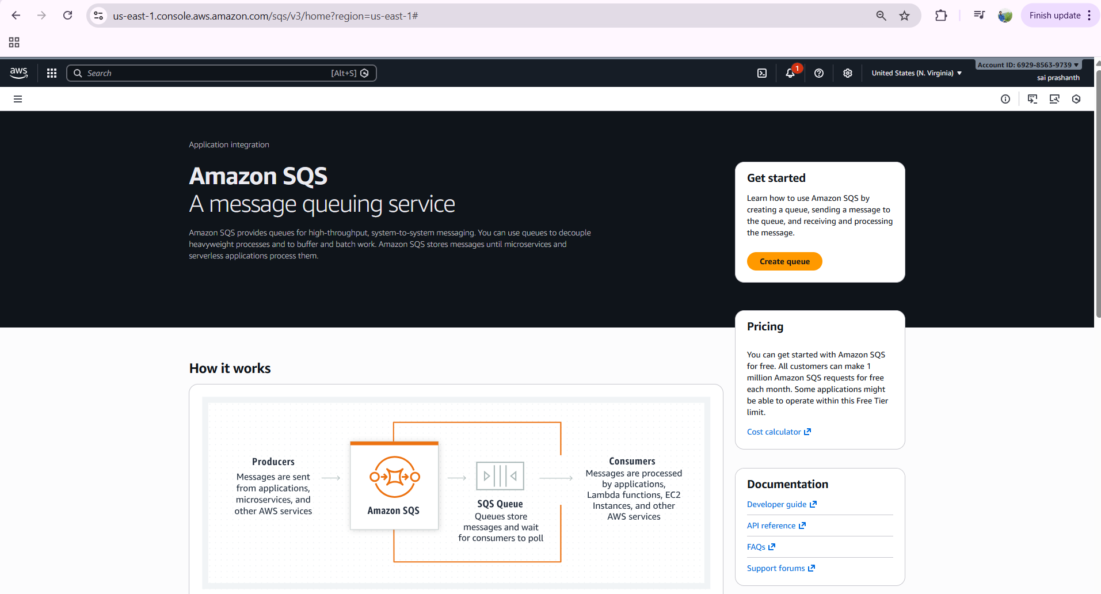
select type as standard
enter one queue name
in encryption you have ssm or kms
you can select any of both
here I selected ssm as it is default

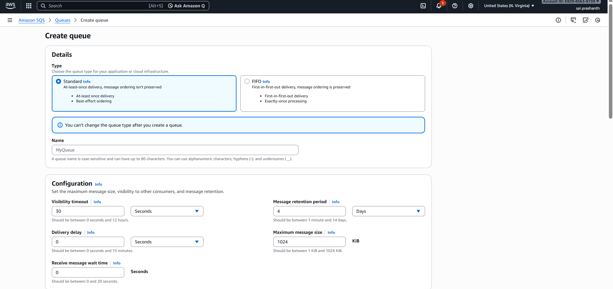
select access policy as basic
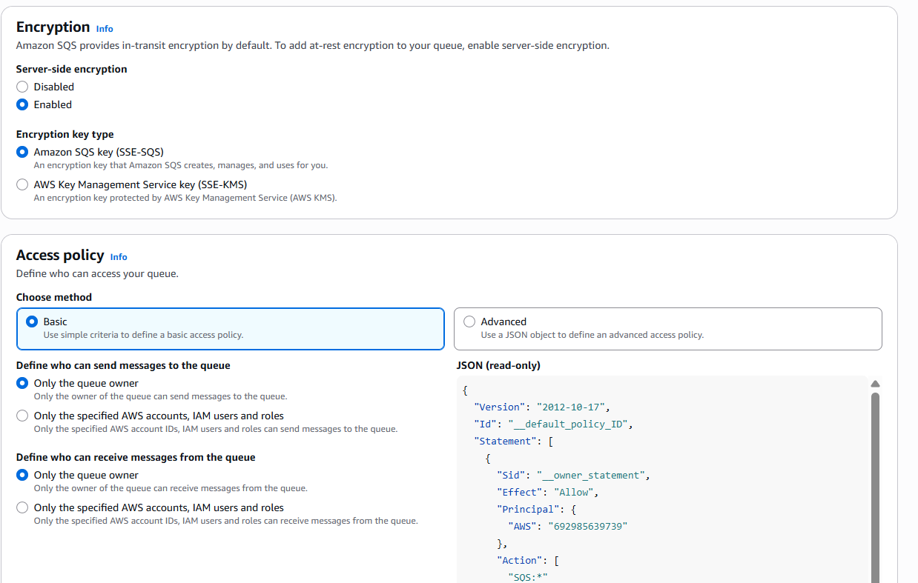

click on create queue---now the queue has been created
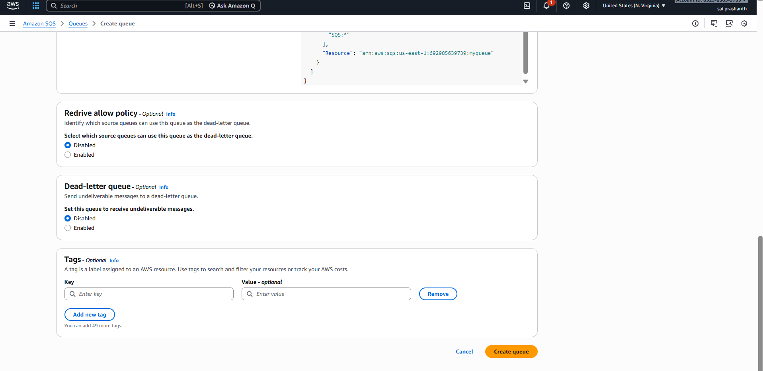
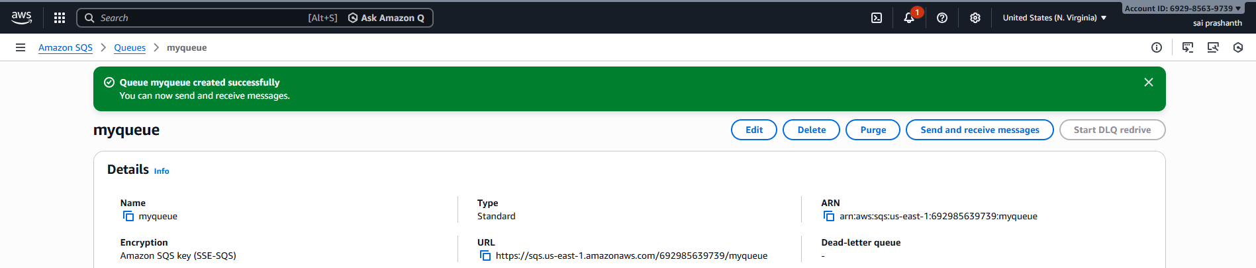
click on send and receive messages to send the message
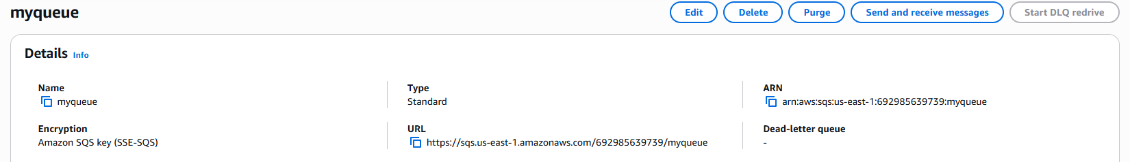
once youi clicked it---give one message to send and click on send message
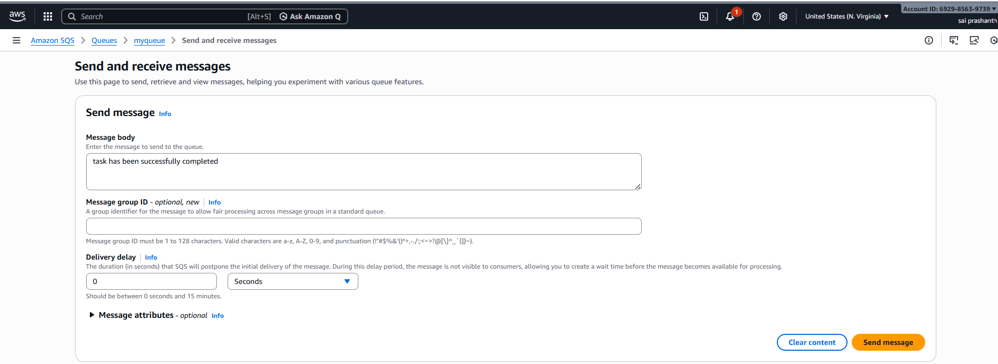

now the message has been sent successfully
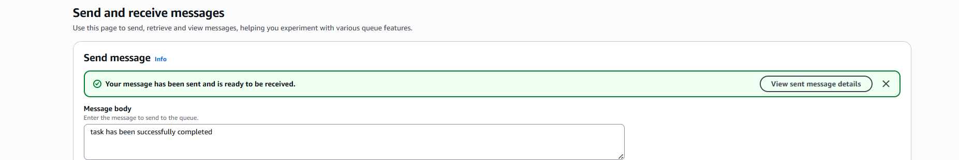
now to receive the message click on poll for messages
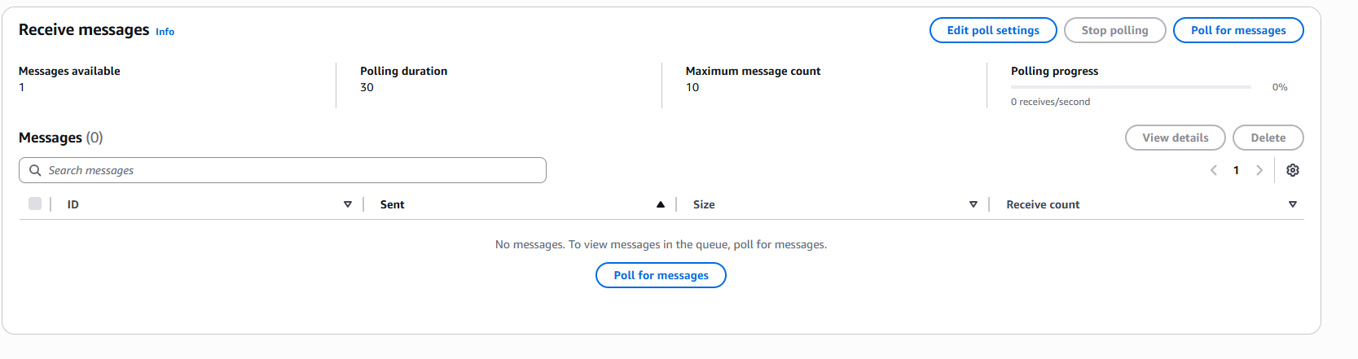
you can see the received message
once the message has been received…. delete the message or else it reappears after visibility timeout
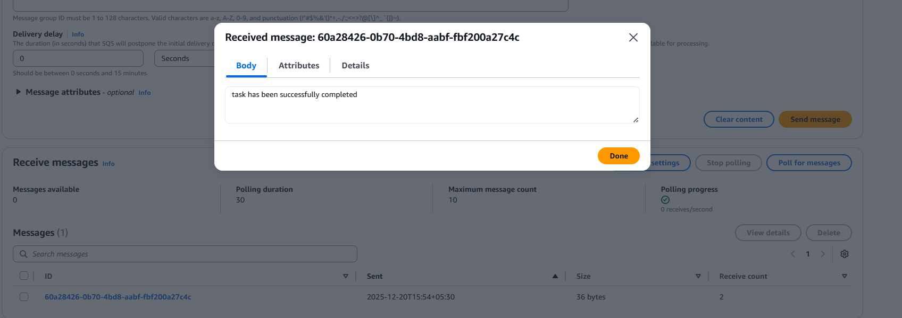
validation steps:
you can see in monitoring tab what are the messages sent and received

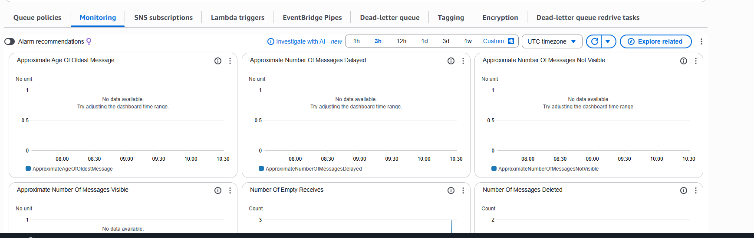
AWS MQ
Objective: The objective of Amazon MQ is to provide a managed message broker service that enables applications to communicate using industry-standard messaging protocols (such as JMS, AMQP, MQTT), making it ideal for migrating and running legacy or enterprise messaging applications on AWS without managing the underlying infrastructure.
prerequisites:
aws account
understanding of message brokers vs message queues
messaging protocols
step by step process:
firt go to AWS MQ---click on create broker
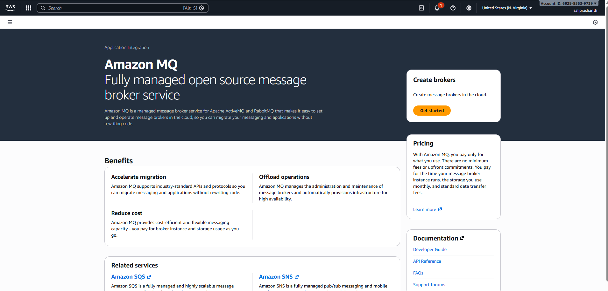

select broker engine
there are two types---rabbit mq and apache active mq
select rabbit mq—next--
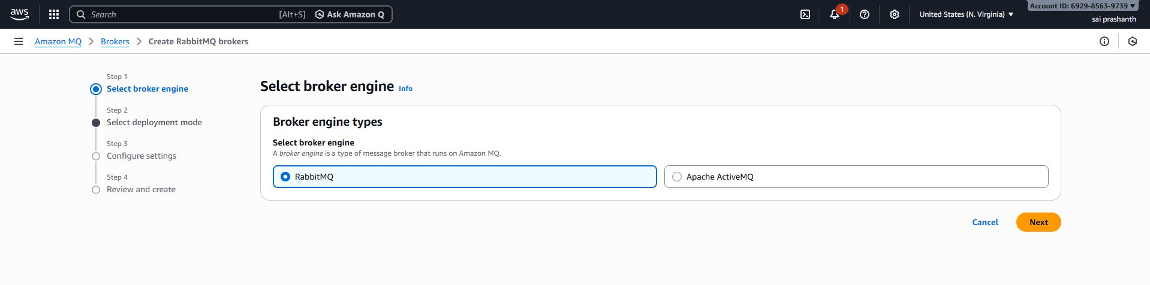
here select the deployment mode as single instance broker and enter the details like broker name, select broker instance type –enter user name and create one password and click on create broker
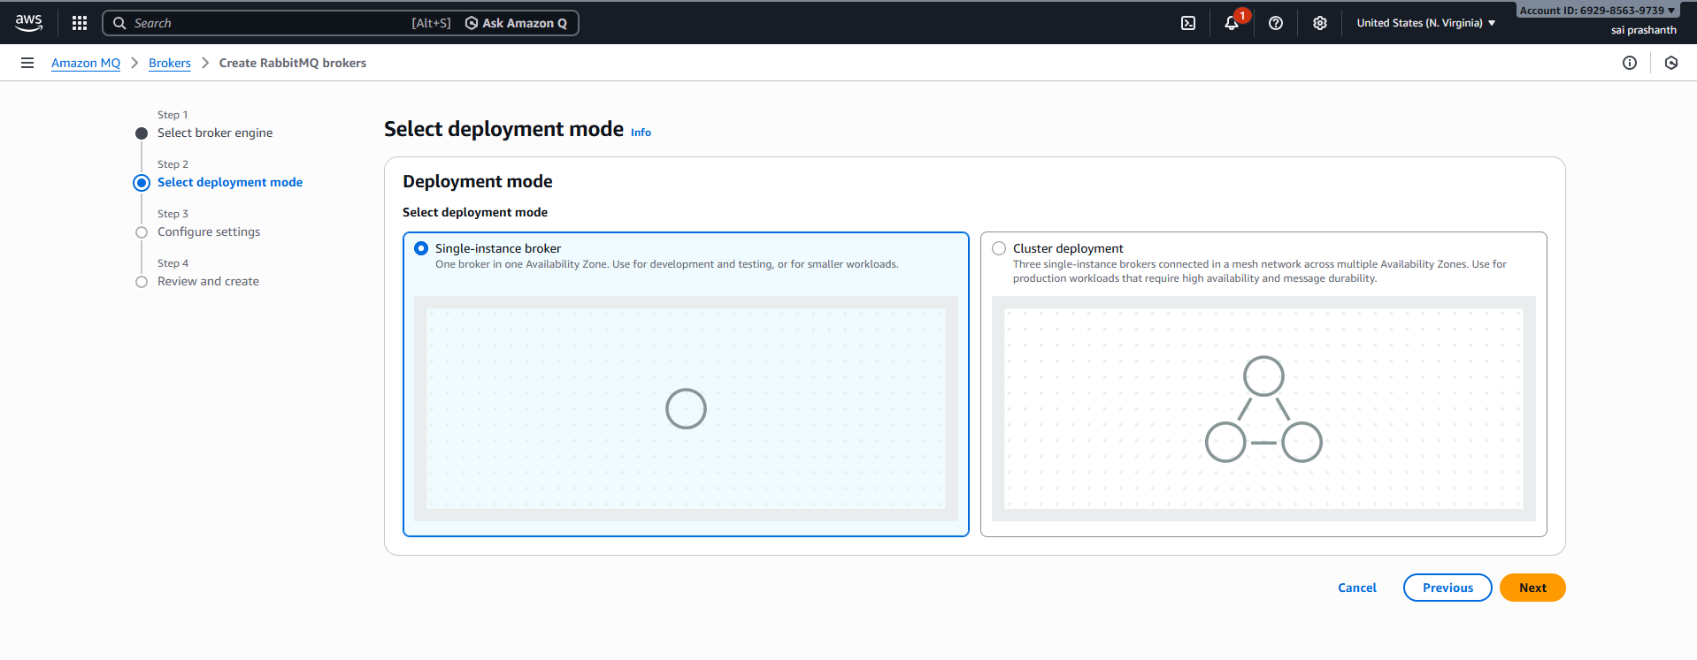
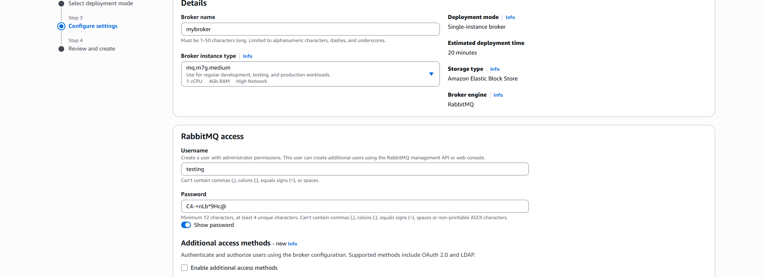
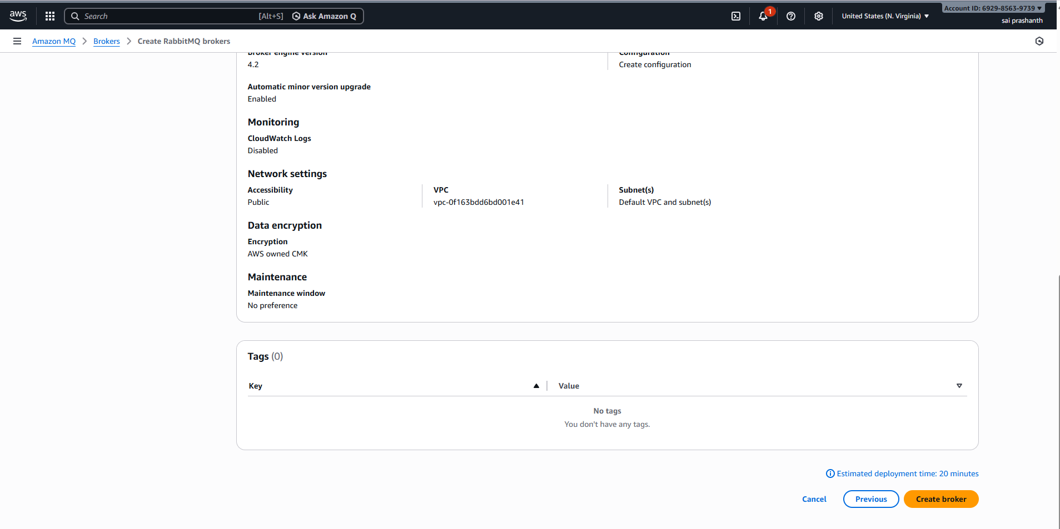

now you can see the broker has been created successfully…
it takes some time to get the status as running
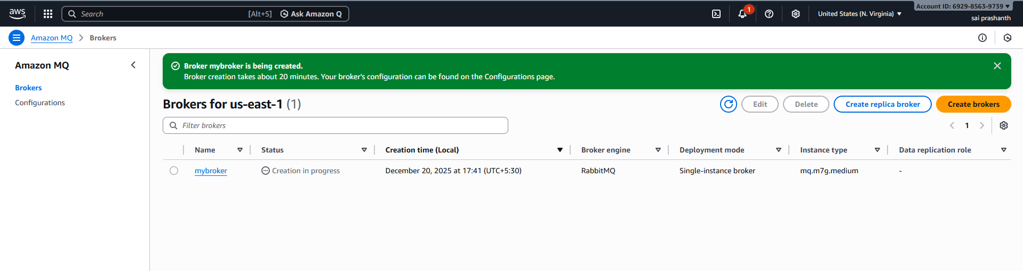
now you can see the status as running
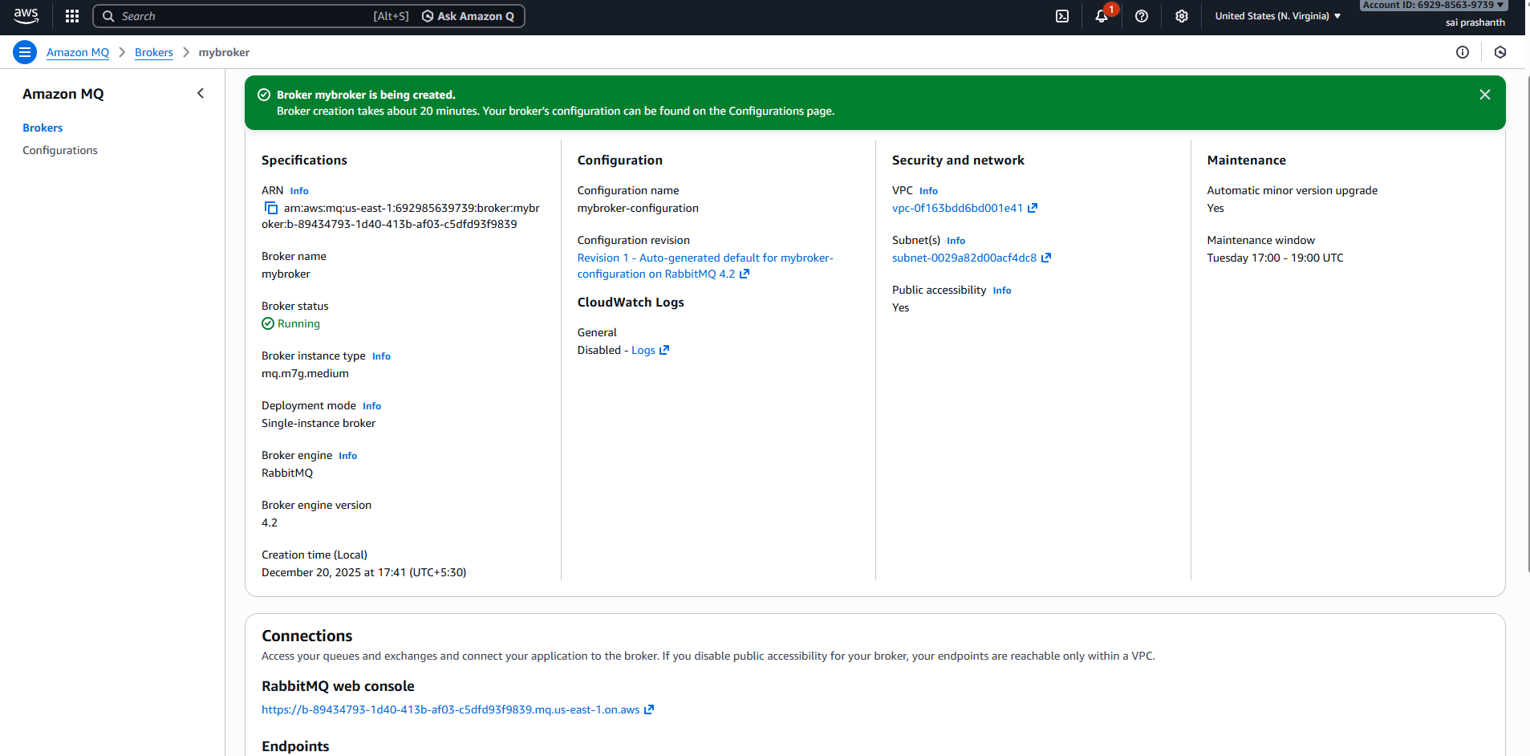
validation steps:
check with the URL link of mq
enter the user’s name and password to get login
you can see the overview of memory diskspace

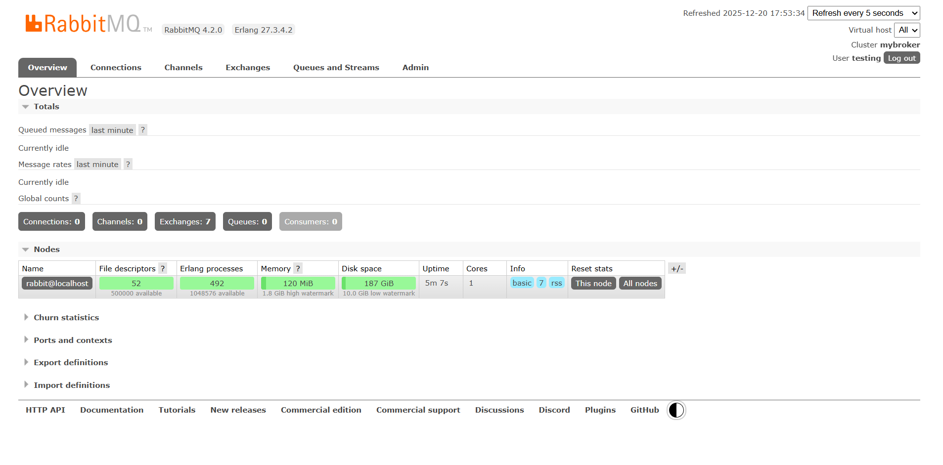
conclusion: Amazon MQ simplifies running traditional message brokers on AWS by providing a fully managed, secure, and highly available messaging service. It is best suited for legacy or enterprise applications that require standard messaging protocols and broker-based communication.

